Does Work Have to Be Miserable? A Deep Dive into Organizational Culture and Job Design

# Introduction

In a world where the normal individual spends a critical parcel of their life at work, the address “Does work got to be miserable?” resounds profoundly. The BBC podcast of the same title investigates this address, and the taking after substance, organized as an intellect outline, dives into the different features that impact the reply.

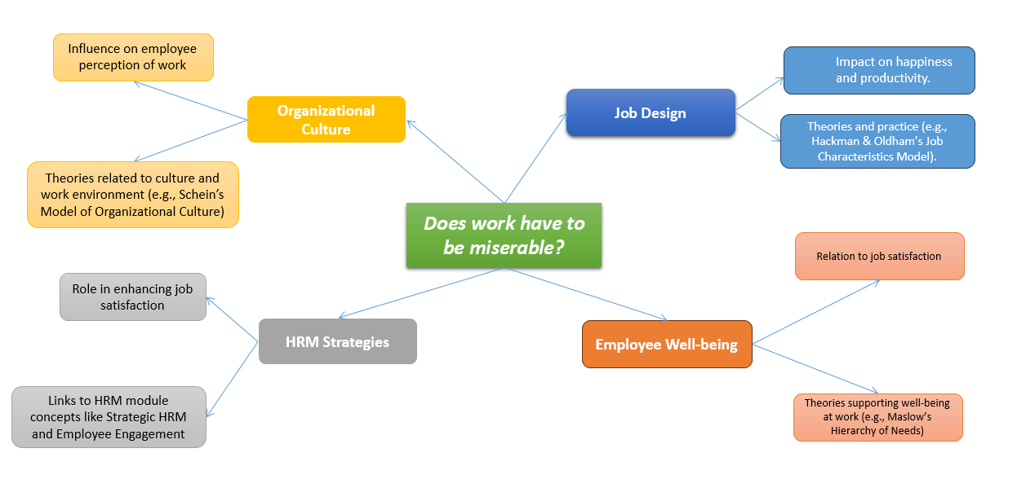

Fig: Mindmap

Source: Self Made

# Organizational Culture: The Foundation of Workplace Satisfaction

Organizational culture is the shared values, convictions, and hones that shape the work environment. It is the undetectable constraint that impacts representative behavior and states of mind. A positive culture can lead to work fulfillment, whereas a poisonous one can make work hopeless. The importance of culture in HRM, noticing that it could be a basic determinant of organizational victory. They contend that a solid, positive culture can pull in and hold ability, drive engagement, and move forward execution.

# Job Design: The Blueprint for Employee Fulfillment

Work plan alludes to the way assignments and duties are organized to meet both organizational objectives and representative needs. The podcast recommends that well-designed occupations can improve bliss and efficiency. Hackman & Oldham's Work Characteristics Demonstrate, a seminal hypothesis in the work plan, sets that occupations ought to be planned to supply expertise assortment, assignment character, errand importance, independence, and criticism (Ali *et al.,* 2014). These center dimensions lead to basic mental states that result in expanded work fulfillment, inspiration, and execution.

# Employee Well-being: The Human Aspect of Work

Employee well-being may be a multifaceted concept that envelops physical, passionate, and mental well-being. The podcast touches on the thought that representative well-being is naturally connected to work fulfillment. Goal-setting hypothesis underpins this idea by proposing that clear and challenging objectives can lead to higher levels of worker well-being and fulfillment (Locke and Latham, 2006). When representatives have a sense of reason and accomplishment, work gets to be more than just a implies to an end—it gets to be a source of fulfillment.

# HRM Strategies: The Tools for Crafting Better Workplaces

Human Asset Administration (HRM) procedures are the strategies and arrangements that organizations utilize to oversee their workforce successfully. A vital part of HRM in adjusting human capital with commerce targets (Boxall and Purcell, 2011). By actualizing methodologies such as comprehensive preparation programs, reasonable remuneration, and openings for career development, HR supervisors can create an environment where work does not need to be hopeless.

# Impact on Happiness and Productivity: The Win-Win Scenario

The podcast recommends a relationship between representative bliss and organizational efficiency. (Gittell *et al.,* 2004) bolster this claim by illustrating that labor relations based on common picks up can lead to forward firm execution. When representatives are upbeat, they are more locked in, inventive, and profitable, which in turn benefits the organization as an entire. (Gittell *et al.,* 2004) give experimental proof that bolsters the idea that when workers feel esteemed and substance, their engagement levels rise, driving improved inventiveness and efficiency. This commonly advantageous relationship isn't as if it were profitable for the workers but also the organization, because it deciphers into superior execution results. The concept of shared picks up in labor relations, as examined by (Gittell *et al.,* 2004), recommends that when managers and workers work together towards common objectives, the outcomes are more favorable than when either party seeks after their interface at the cost of the other. This collaborative approach can show in different shapes, such as shared decision-making, open communication, and reasonable remuneration hones. By executing these techniques, organizations can make an ethical cycle where worker bliss bolsters into organizational victory, which in turn strengthens representative joy.

# Theories and Practice: The Academic Backbone of HRM

The podcast's discoveries are bolstered by a run of hypothetical systems. (Edwards, 2003) talks about the adjustment between worker needs and organizational requests in mechanical relations. This adjustment is pivotal for guaranteeing that work isn't hopeless. By understanding the speculations behind work plans and organizational culture, HR directors can apply best hones to form a work environment that advances bliss and efficiency. (Edwards, 2003) gives a comprehensive investigation of this adjustment, emphasizing that the key to a non-miserable work environment lies in harmonizing the interface of workers with the strategic targets of the organization. This harmony is fundamental for cultivating a work environment where representatives feel esteemed and propelled, and where efficiency is optimized. Edwards' work sheds light on the complexities of mechanical relations, highlighting the significance of understanding the working relationship from both the representative and boss viewpoints. He contends that successful mechanical relations hones must consider the financial, social, and mental perspectives of work. This all-encompassing approach guarantees that employees' needs for reasonable compensation, work security, important work, and regard are met, whereas too tending to the organization's requirements for effectiveness, versatility, and productivity. Moreover, (Edwards, 2003) examines the effect of broader societal and financial patterns on mechanical relations, counting globalization, mechanical alter, and the move towards more individualized work connections. These variables have noteworthy suggestions for work plans and organizational culture, challenging HR supervisors to adjust their hones to stay relevant and compelling in a quickly changing world.

# Linking Theory to Practice: The Role of HRM Modules

The concepts displayed within the HRM module complement the thoughts talked about within the podcast. Key HRM, employee engagement, and organizational behavior are some of the concepts that can be connected to the podcast's subject. By referencing important writing, such as (Gold *et al.,* 2017) on worker relations and voice, and (Hook and Jenkins, 2019) on presenting HRM, HR directors can extend their understanding of how to formwork way better. The HRM module concepts, such as vital HRM, worker engagement, and organizational behavior, give important experiences that adjust with the podcast's dialog on moving forward in the working environment. Key HRM guarantees that HR hones bolster the organization's objectives, whereas worker engagement centers on the passionate commitment of representatives to their work and the company. Organizational behavior makes a difference get it the flow inside the work environment and how it influences execution. By coordinating these concepts, HR supervisors can make a more satisfying work environment that advances both worker fulfillment and organizational efficiency. The writing, and counting (Gold *et al.,* 2017) on representative relations and HRM, offer direction on implementing these procedures successfully. The objective is to set up a working environment where work is engaging and fulfilling, contributing to the general victory of the organization.

# Conclusion

The address posed by the BBC podcast “Does work ought to be miserable?” opens up a wealthy dialog on the role of organizational culture and work plan in forming the work encounter. By looking at these concepts through the lens of scholastic hypothesis and HRM practices, it gets to be clear that work does not have to be hopeless. Instep, it can be a source of fulfillment, development, and fulfillment. The challenge for HR supervisors is to apply the bits of knowledge from the podcast and the supporting writing to make work environments where representatives can flourish.

# 

# Reference List

Locke, E.A. and Latham, G.P., 2006. New directions in goal-setting theory. *Current directions in psychological science*, *15*(5), pp.265-268.

Ali, S.A.M., Said, N.A., Abd Kader, S.F., Ab Latif, D.S. and Munap, R., 2014. Hackman and Oldham's job characteristics model to job satisfaction. *Procedia-Social and Behavioral Sciences*, *129*, pp.46-52.

Boxall, P. and Purcell, J., 2022. *Strategy and human resource management*. Bloomsbury Publishing.

Gittell, J.H., Von Nordenflycht, A. and Kochan, T.A., 2004. Mutual gains or zero sum? Labor relations and firm performance in the airline industry. *Ilr Review*, *57*(2), pp.163-180.

Edwards, P., 2003. The employment relationship and the field of industrial relations. *Industrial relations: theory and practice*, *2*, pp.1-36.

Gold, J., Holden, R. and Iles, P., 2017. *Human resource development: Theory and practice*. Bloomsbury Publishing.

Hook, C. and Jenkins, A. (2019) Introducing Human Resource Management, Pearson. Chapter 6.